DC++ Directions… as of 9/05

Ok I’m going to try and make this as simple as possible.. These directions assume you know how to use a computer btw

If you haven’t yet, go to http://www.rhstevenson.com/DC++.exe and download and install the client.

Now, we’re going to set it up: Go to File->Settings
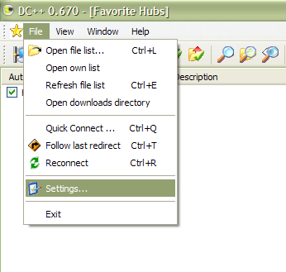
Now we’re going to put in your name…It can be anything you want

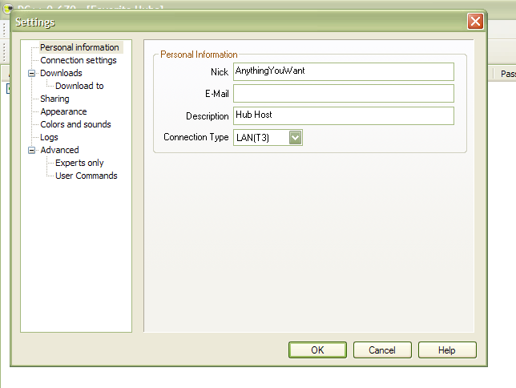

This next step is crucial:
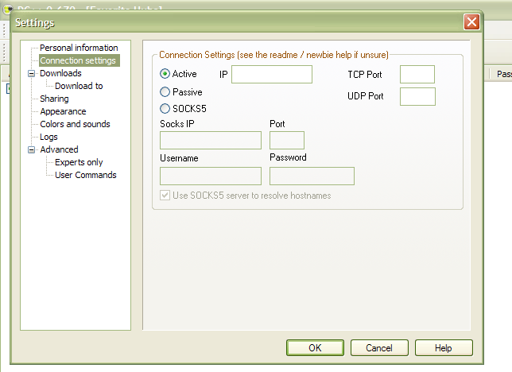

FOR THE LOVE OF GOD DON’T PUT ANYTHING IN THAT IP BOX
NOTHING NEEDS TO GO IN THERE, SO DON’T TOUCH IT
Also make sure Active is selected

Now we’re going to set up the sharing.. Just add the folder that you have stuff in.. I recommend that you make your download folder and shared folder the same…
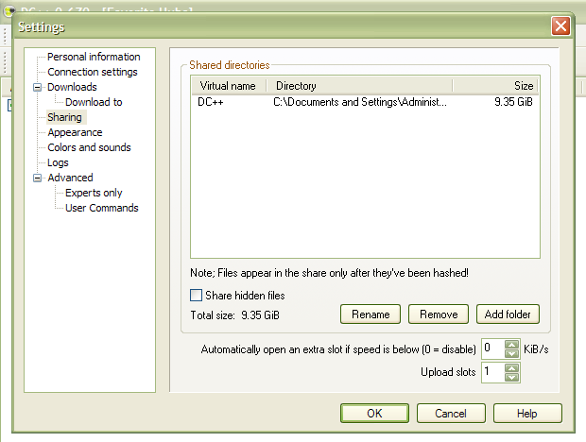

Ok one more thing… To actually connect to DC++
Click on the yellow star
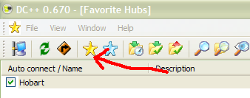
Now click on the ‘New’ button near the bottom of the screen:
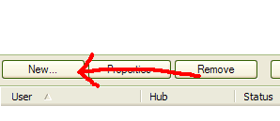

Enter the information EXACTLY as shown here:
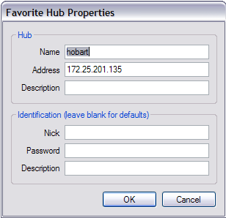
172.25.201.135 ← Just copy and past this

Click OK and then double click the hub to connect

